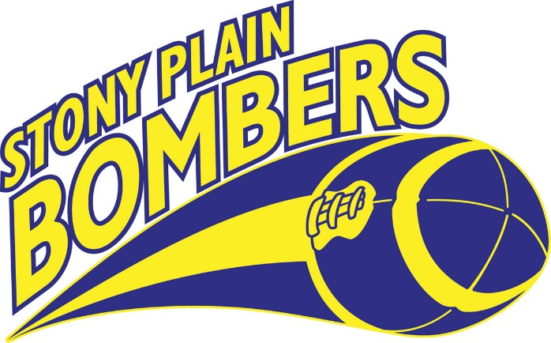

Apparel Items
Yellow T-Shirts - $5 Blue Polyester T-Shirts - $10
Shorts no pockets- $5 Shorts with pockets - $10
Cinch Pack Blue or Yellow- $5

***Package Deal***
Buy a t-shirt and pair of shorts and get cinch pack for FREE!

Black Flat Brim Hat – $20 Scarves - $15
Water Bottles - $5 Travel Tumbler - $10.50
Banduz - $10 Golf Umbrella - $22.50
Blanket - $16.50 Touch Screen Mitts - $8

Keepsake Helmets- $20 *Old,Old* Jerseys- $5

Thank you for supporting Stony Plain Minor Football!

